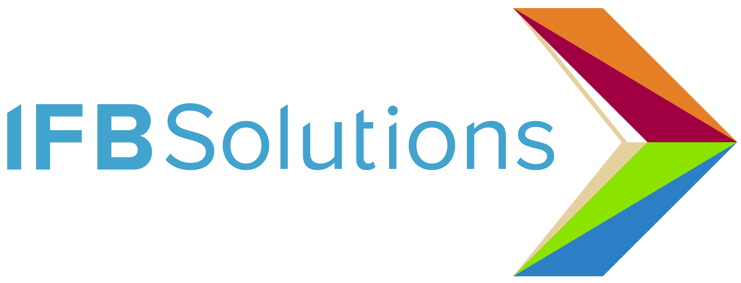

Quick Facts: Fighting to Protect Jobs for People who are Blind

Situation Summary
IFB Solutions has been serving the blind community since 1936, and now we face a grave threat to our mission of employing, training and serving people who are blind or visually impaired.

On June 3, 2019, we were notified by the Department of Veterans Affairs (VA) that it would begin terminating our long-standing contracts to produce eyeglasses for military veterans and their families. These contracts, which IFB Solutions has held since 2000, provide employment for 137 IFB Solutions employees who work in our optical lab, including 76 people who are blind and 15 veterans. Together, our employees produce with great pride approximately 1,200 pairs of eyeglasses each day.

The VA’s contracting decisions are the result of procurement policy changes following a recent court order that the Rule of Two as currently outlined in the Veterans Benefits Act gives priority to veteran-owned companies over AbilityOne nonprofits like IFB Solutions. IFB Solutions has been fighting that legal interpretation for three years.

By the Numbers

Nearly 1,000 individuals employed by IFB Solutions.

800 jobs for people who are blind could be lost once VA contracts are shifted away.

70 percent of working-age adults who are blind are not employed.

6,000 people who are blind are employed by National Industries for the Blind and its associated nonprofit agencies like IFB Solutions

A person who is blind is twice as likely as a sighted peer not to return to the workforce.

54 percent of the IFB Solutions workforce has relocated to our facilities to work for us.

1,200 pairs of eyeglasses, on average, are produced each day by the IFB Solutions optical lab

More than 950 veterans are served each day by the IFB optical lab at 38 VA locations in five states, representing a total of 240,000 veterans each year.

More than 2.5 million pairs of eyeglasses have been produced by IFB Solutions since the program began.

Key Terms & Players

IFB Solutions (IFB) – Formerly known as Winston-Salem Industries for the Blind, IFB Solutions is the largest employer of people who are blind or visually impaired in the country. IFB was started in 1936 in Winston-Salem by the Lions Club. Today, the nonprofit provides employment, training and services for people who are blind or visually impaired with operations in Winston-Salem, Asheville, and Little Rock, Ark. IFB funds employee training and services as well as community programs, making possible the SEE program for children who are blind or visually impaired, IFB Community Low Vision Centers across North Carolina and in Little Rock, Ark., and Tracy’s Little Red Schoolhouse based in Winston-Salem. www.ifbsolutions.org

NIB (National Industries for the Blind) - The nation’s largest employment resource for people who are blind, and through its network of associated nonprofit agencies, is the largest employer of people who are blind in the country. IFB Solutions is part of NIB’s network of nonprofit agencies. NIB connects its associated agencies with contract opportunities with the federal government and commercial companies.

AbilityOne Program - The AbilityOne program is a federal statute formerly known as the Javits-Wagner O’Day (JWOD) Act. It was established by Congress in 1938 to create jobs for people who are blind or severely disabled, and today is among the largest sources of employment in the United States for individuals who are blind or have significant disabilities.

The program is administered by the U.S. AbilityOne Commission, an independent Federal agency which has designated National Industries for the Blind, SourceAmerica and the American Foundation for the Blind as the central nonprofit agencies facilitating the program. The AbilityOne Commission maintains a Procurement List of products or services that have been placed in the AbilityOne Program. Once a product or service is put on the Procurement List, the federal government must buy it from the organization designated by the Commission until the government no longer has a need for that item or the organization can no longer furnish the item.

The Rule of Two - federal statute set forth in the Veterans Benefits Act of 2006 requiring that VA contracting officers first determine whether two or more veteran-owned small businesses can meet the VA’s need at reasonable prices before procuring from the AbilityOne Procurement List. By giving veteran-owned small businesses priority over AbilityOne agencies, the Rule of Two has the potential to drastically reduce the number of jobs for people who are blind or severely disabled employed by AbilityOne agencies.

VISN – The VA’s Health Administration is divided into 21 geographical areas called Veterans Integrated Service Networks.

IFB Optical History and General Statistics

1996 IFB Solutions identifies eyeglasses as a business opportunity and invests in building an optical lab and training its employees in the field.

2000 IFB Solutions awarded its first contract with the Dept of Veterans Affairs in VISN 7

2006 IFB awarded the contract to serve VISN 2

2007 IFB awarded the commercial contract to serve five locations in VISN 8 (these locations were then added to the AbilityOne Procurement List in 2014)

2015 4 additional locations in VISN 8 added to the AbilityOne Procurement List, expanding IFB’s long-term contract.

2015 IFB invests $1.2 million to expand its optical lab

2018 IFB invests $1.8 million in capital improvements to its optical lab

Timeline: AbilityOne Program & The Rule of Two
Prior to 2016, the AbilityOne Program and the 2006 Veterans Benefits Act were able to coexist and successfully create opportunities for people who are blind, as well as veteran-owned small businesses. However, a series of legal efforts has created the current situation of AbilityOne agencies losing contracts with the VA, and with those contracts, life-changing jobs for people who are blind or severely disabled.

2006 Congress passes the Veteran Benefits Act (VBA), intended to expand opportunities for veteran-owned businesses. One component of the VBA—known as the “Rule of Two”—requires the VA to set aside contracts if two or more veteran-owned businesses can submit fair offers.

How the Rule of Two will work alongside the AbilityOne Program, which is a mandatory source for products and services on the AbilityOne Procurement List, is not specified.

2010 The Department of Veterans Affairs (VA) confirms that all items on the AbilityOne Procurement List as of January 7, 2010 will continue to receive preference. The VA determines it will not propose new items for the Procurement List unless the Rule of Two is first satisfied.

2016 In June 2016, the U.S. Supreme Court decides the case of Kingdomware Technologies v. United States, which holds that the VA is required to adhere to the Rule of Two when awarding a contract. In its first response to Kingdomware, the VA issues a Class Deviation that still gives mandatory priority to the AbilityOne Program.

In August 2016, a veteran-owned small business with optical contracts with the VA files a federal complaint against the U.S. Government specific to VA optical contracts held by IFB Solutions arguing that the Rule of Two must first be applied. IFB Solutions files as an intervener in support of the Federal Government’s defense.

2017 In February 2017, the VA amends its Class Deviation to require that the Rule of Two first be
applied to AbilityOne products and services added to the Procurement List after January 7, 2010.

In May 2017, the U.S. Court of Federal Claims rules in favor of the veteran-owned small business in its complaint against the U.S. Government. In July, IFB files a notice of appeal and in September, is granted a stay in the VA’s procurement policy changes.

2018 In October 2018, the U.S. Court of Appeals for the Federal Circuit upholds the lower court decision in favor of the veteran-owned small business.

2019 In March 2019, IFB files a petition for rehearing its appeal. That petition is denied in May, the Court issues its final order.

In May 2019, The VA issues a Class Deviation for contracting officers to apply the Rule of Two before procuring items from the AbilityOne Procurement List.

In June 2019, The VA begins communications with IFB Solutions and other AbilityOne agencies that it plans to end certain contracts. IFB’s first optical contract is set to expire June 30, 2019. It is extended to July 31, 2019.

